**ARIZONA PEACE OFFICER STANDARDS AND TRAINING BOARD**

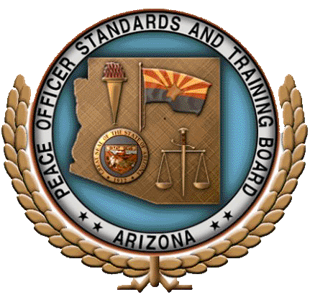

**MILITARY POLICE**

**TRANSITION TRAINING PROGRAM**

**Applicant Entry Criteria Guide**

**2015**

**Arizona Peace Officer Standards and Training Board**

**(AZ POST)**

**Military Police Transition Training Program**

**(MPTTP)**

**Applicant Entry Criteria**

The purpose of this guide is to assist applicants and the training delivery site personnel in identifying the supporting documentation necessary for the application process. These criteria are in addition to meeting all of the AZ POST Minimum Qualifications for Appointment standards required of any applicant. Each applicant is responsible for providing complete documentation substantiating their qualifications.

*In order to be eligible for the Military Police Transition Training Program (MPTTP) the applicant must meet the following:*

1. **Have performed as a military police officer for a minimum of 2080 hours in a specified law enforcement occupational specialty (MOS).**

AZ POST uses the term “military police” in a general sense, as a way to describe military law enforcement personnel associated with The United States Armed Forces. Each branch of the military has their own unique verbiage when describing military police personnel and/or programs. Care should be taken to ensure the information presented by a candidate does in fact document actual time served in a law enforcement assignment.

*Applicants will provide copies of any/all of the forms listed below that apply to their time as an MP:  
 a. Military Occupational Specialties (MOS)  
 b. Enlisted Record Brief (ERB)  
 c. Officer Record Brief (ORB)*

1. **Have satisfactorily completed military police training at a federal service school.**

Federal Service Schools:

Air Force U.S. Air Force Security Forces Center/Academy, Lackland Air Force   
 Base, Texas

Army U.S. Army Military Police School, Ft. Leonard Wood, Missouri

Coast Guard U.S. Coast Guard Maritime Law Enforcement Academy, Federal Law   
 Enforcement Training Center, Charleston, South Carolina

Marines U.S. Military Police Basic Officers Couse, Ft. Leonard Wood, Missouri

Navy Law Enforcement/Master-at-Arms at the Naval Technical Training Center,   
 Lackland AFB, San Antonio, Texas

**(2)**

1. **Their basic training and in-service training records must demonstrate substantial comparability to Arizona’s full-authority peace officer basic training course.**
2. **Either possess an honorable discharge form, or be currently serving.**
3. **Have discontinued employment in the specified law enforcement MOS, ERB/ORB for no more than five years before the start of the program.**

The “DD214” is the most commonly known Department of Defense verification of discharge form. Information regarding this form is available on the internet from a variety of websites (<http://dd214.us/> for example). This form contains the following information:

* Date and place of entry into active duty
* Home address at time of entry
* Date and place of release from active duty
* Home address after separation
* Last duty assignment and rank
* Military job specialty
* Military education
* Decorations, medals, badges, citations, and campaign awards
* Total creditable service
* Foreign service credited
* Separation information (type of separation, character of service, authority and reason for separation, separation and reenlistment eligibility codes)

AZ POST recognizes the DD214 as a valid form of proof of the above detailed information.

*In the event an applicant has not separated from the military and cannot supply a DD214 form*, that applicant shall be required to provide a letter of support from their Commanding Officer (CO) detailing the following:

* The military occupational specialty (MOS) the applicant is performing
* The length of time assigned to that MOS
* The applicable ERB/ORB detailing all assignments
* Current rank
* Decorations, medals, badges, citations, and campaign awards
* If the applicant is recommended by the CO to attend the MPTTP

Encourage applicants to provide copies of any diplomas, awards, and Verification of Military Experience and Training (VMET) documents.

1. **They must pass each block of the Comprehensive Final Exam (CFE) with a minimum of 70%.**
2. **In addition to the examination required in item #6 above, the applicant must satisfactorily perform the practical demonstrations of proficiency; Peace Officer Physical Aptitude Test (POPAT), vehicle operations, pursuit operations and firearms qualifications.**

**(3)**